Click and type the title of your article, only capitalize first word and proper nouns

First-name Surname^{1*}, Second-name Surname² and Third-name Surname³

¹Affiliation 1, Email address, University, City, Country

*Corresponding Author

ABSTRACT

An Abstract is required for every article; it should succinctly summarize the reason for the work, the main findings, and the conclusions of the study. The abstract should be no longer than 250 words. Do not include artwork, tables, elaborate equations or references to other parts of the article or to the reference listing at the end. The reason is that the Abstract should be understandable in itself to be suitable for storage in textual information retrieval systems.

Keywords: ; ; ; ;

- Introduction

An overview about the data you are analysing to answer the analysis questions.

- Body section

- Conclusion

Restate the main results of your analysis and provide any future recommendations.
Acknowledgments

Acknowledgments should be inserted at the end of the article, before the references. When citing names within the Acknowledgment, do not use Mr., Mrs., Ms., or Miss. List first initial and last name only. Use the Dr. or Prof. title with each name separately; do not use plural Drs. or Profs. with lists of names.

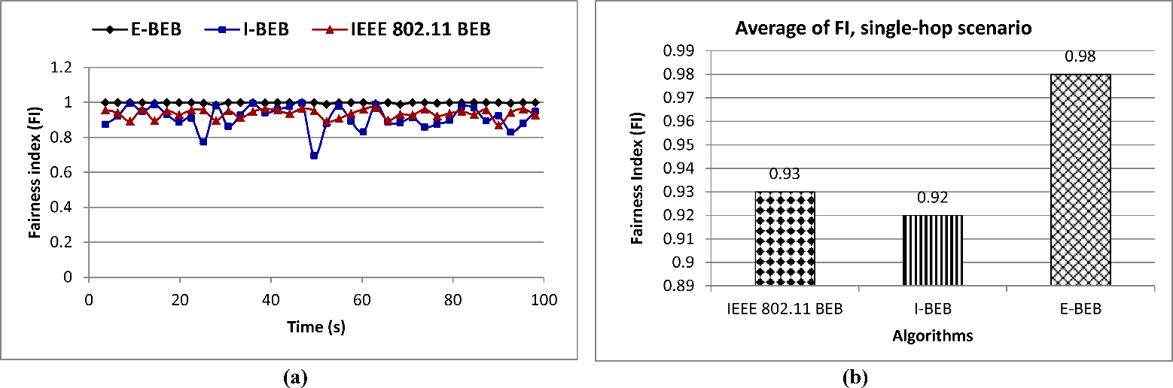
Figure 1. (a) Fairness index, (b) Average Fairness Index

Table 1. Table, version 1

Parameter | Value | Parameter | Value
Slot time | 20 μs | Slot time | 20 μs
ACK size | 20 bytes | ACK size | 20 bytes
RTS size | 25 bytes | RTS size | 25 bytes
CTS size | 20 bytes | CTS size | 20 bytes
Data packet size | 1000 bytes | Data packet size | 1000 bytes
DIFS interval | 40 μs | DIFS interval | 40 μs
SIFS interval | 10 μs | SIFS interval | 10 μs
CWmin | 31 | CWmin | 31
CWmax | 1023 | CWmax | 1023
Bandwidth | 2 Mbps | Bandwidth | 2 Mbps
Transport protocol | UDP | Transport protocol | UDP

  - Article Size

The Manuscript should be prepared in English language by using MS Word. Article can be up to 12 pages inclusive references and abstract.
Supply some 3–5 keywords, separated with semicolons, e.g., Azomethine ylide; Claisen rearrangement; Diels-Alder cycloaddition; Enantioselective catalysis; Ionic liquid; Metathesis; Microwave-assisted synthesis.

References

Use APAv7 Template for references formatting. here’s a short, practical summary of APA 7th edition you can keep as a quick reference for both in-text citations and the reference list:

APA 7 – Quick Summary

✏️ In-Text Citations (inside your paper)
APA uses Author–Year (not numbers).

One author: (Smith, 2023)

Two authors: (Smith & Lee, 2023)

Three or more authors: (Smith et al., 2023)

Direct quotation: Include page number: (Smith, 2023, p. 15)

Multiple sources in one citation:
Alphabetical order, separated by semicolons: (Ali, 2022; Smith et al., 2021)

Narrative citation (author in sentence): Smith (2023) reported that…

APA 7 – Common Reference Formats (with Examples)

📘 Journal Article
Format
Author, A. A. (Year). Title of article. Journal Title, Volume(Issue), pages. DOI/URL
Example
? fo0076gAli, M., Khan, S., & Ahmed, R. (2023). Cybersecurity risk assessment using machine learning techniques. Computers & Security, 124, 102987. https://doi.org/10.1016/j.cose.2022.102987

📕 Book
Format
Author, A. A. (Year). Title of book (Edition). Publisher.
Example
Stallings, W. (2018). Effective cybersecurity: A guide to using best practices and standards (2nd ed.). Addison-Wesley.

📗 Conference Paper
Format
Author, A. A. (Year). Title of paper. In Proceedings of Conference Name (pp. xx–xx). Publisher. DOI/URL
Example
Zhang, Y., Li, H., & Chen, X. (2022). Intrusion detection using deep neural networks. In Proceedings of the IEEE International Conference on Communications (pp. 1452–1457). IEEE. https://doi.org/10.1109/ICC45855.2022.9838912

🎓 Thesis / Dissertation
Format
Author, A. A. (Year). Title (Master’s thesis/Doctoral dissertation). University. URL (if online)
Example
Alqahtani, S. (2021). Security governance frameworks for cloud environments (Master’s thesis). King Saud University.

🌐 Website
Format
Author/Organization. (Year). Title of page. Website name. URL
Example
National Institute of Standards and Technology. (2023). Cybersecurity framework 2.0. NIST. https://www.nist.gov/cyberframework

🧾 Technical Report / Standard
Format
Organization. (Year). Title of report (Report No.). Publisher. URL
Example
National Institute of Standards and Technology. (2020). Security and privacy controls for information systems and organizations (SP 800-53 Rev. 5). https://doi.org/10.6028/NIST.SP.800-53r5

✅ Bonus: In-Text Citation Examples (APA)
- Parenthetical: (Ali et al., 2023)
- Narrative: Ali et al. (2023) showed that…
- Direct quote: (Stallings, 2018, p. 42)

  - Tables, figures and schemes

All citations of figure and tables in text must be in numerical order. Citations to figures in text always carry the word “Figure.”, “Table.” followed by the figure/table number.
You can choose to display figure/table through one column (see Table 1, Figure 1) or across the page (see Table 2, Figure 2). Remember that we will always also need high-resolution versions of your figures for printing in (i.e. TIFF) format.

Table 2. Table, version 2

Parameter | Value
Slot time | 20 μs
ACK size | 20 bytes
RTS size | 25 bytes
CTS size | 20 bytes
Data packet size | 1000 bytes
DIFS interval | 40 μs
Bandwidth | 2 Mbps
Transport protocol | UDP

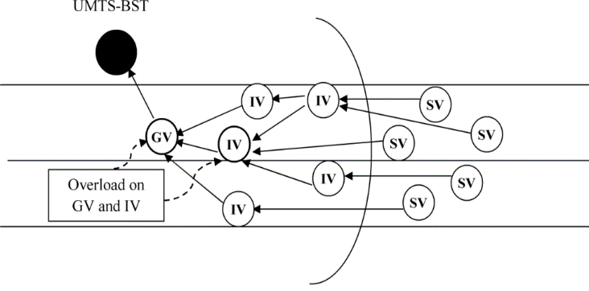
Figure 2. Overload on GV and IV vehicles

  - Lists

For tabular summations that do not deserve to be presented as a table, lists are often used. Lists may be either numbered or bulleted. Below you see examples of both.
- The first entry in the list
- The second entry
- A subentry
- The last entry

- A bulleted list item
- Another one

You can use the Bullets and Numbering options in the ‘Formatting’ toolbar of Word® to create lists. Note that you should first block the whole list. A sublisting is coded using the ‘Increase Indent’ (go to a sublevel of numbering) and ‘Decrease Indent’ (go to a higher level of numbering) buttons.

  - Equations

Equations within an article are numbered consecutively from the beginning of the article to the end. All variables are italic. (e.g., x, y, n). Function names and abbreviations are Roman (sin, cos, sinc, sinh), as are units or unit abbreviations (e.g., deg, Hz,) complete words (e.g., in, out), and abbreviations of words (e.g., max, min), or acronyms (e.g., SNR).
You can type your equations and use the symbols in the Word® equation editor or in MathType™. Using the ‘Insert Equation’ option, you can create equations in the Word® equation editor, or if the MathType™ equation editor is installed on your computer.
(1)

